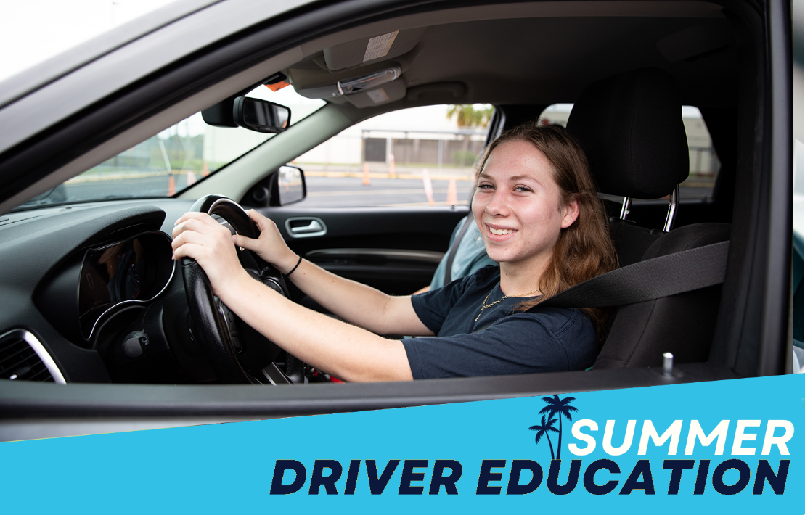

**Session Information:**

* Camp 1 will take place 6/2/25 – 6/13/25 (Monday – Friday)
* Camp 2 will take place 6/16/25 – 6/27/25 (Monday – Friday)
  + Both camps will offer the following sessions: 7:30am – 10:30am; 11:00am – 2:00pm and 2:30pm – 5:30pm

For all information regarding the Licensing and Permit Requirements for the State of Florida, please visit [www.flhsmv.gov](https://www.flhsmv.gov/driver-licenses-id-cards/licensing-requirements-teens-graduated-driver-license-laws-driving-curfews/)

|  |  |  |
| --- | --- | --- |
| **Site** | **Camp 1 6/2/25 – 6/13/25 (Monday – Friday)** | **Camp 2 6/16/25 – 6/27/25 (Monday – Friday)** |
| **Dunedin High** | <https://gofan.co/event/3164419?schoolId=FL13483> | <https://gofan.co/event/3178472?schoolId=FL13483> |

***Questions and Concerns may be directed to***[***DriversEducation@pcsb.org***](mailto:DriversEducation@pcsb.org)***or (727)588-6124***

***Payment is due at the time of registration.  No refunds will be issued.***